**Course Description**: Introduction to the major families of organic compounds: Alkanes, alkenes, alkynes, alkyl halides, aldehydes and ketones, carboxylic acids, aliphatic amines, phenols and ethers (nomenclature, preparation, reactions and qualitative analysis).

**Credit Factor**: 3.0 (Lectures 30 HRS, Practical sessions 30 HRS)

**Course Objectives:**

1. Name organic compounds using the IUPAC nomenclature rules.
2. Describe common preparation methods and reactions for organic compounds.
3. Describe simple qualitative tests in the laboratory for identifying various functional groups of organic compounds.

**Learning Outcomes:** At the end of the course, learners should be able to:

1. Write correct structures of organic molecules and apply IUPAC rules in naming them.
2. Identify hybridization schemes and functional groups in organic molecules.
3. Describe the common preparation methods for the various families of organic molecules.
4. Describe and explain the common reactions of the various families of organic molecules undergo.
5. Distinguish different families of organic molecules using simple qualitative analytical tests.

**Lecturers**:

**\*Mr. Wanjau, Dr. Mwangi, Dr. Okanga, Dr. Amadi, Mr. Mzuga & Mrs. Mayaka**

| **WEEK** | **COURSE OUTLINE** | **PRACTICALS** | |
| --- | --- | --- | --- |
| 1-2 | **Introduction to Organic Chemistry:** Electronic configuration of carbon; Hydrocarbons - hybridization: sp3, sp2 and sp. Catenation; Elemental analysis (qualitative): Empirical and molecular formula. | |  | |
| 3-5 | **Alkanes**: Sources, nomenclature, structural isomerism, physical properties, preparations. **Chemical reactions**: combustion, mechanism for free radical substitution.**Cycloalkanes** (Monoclic & bicyclic): nomenclature, geometric isomerism, uses. | | Determination of melting point and boiling point. | |
| 6-7 | **Alkenes**: Sources, preparation, nomenclature, structural isomers and geometric isomers (E-Z), physical properties. **Chemical reactions** (addition and oxidation). Identification and analysis. Polymerization.Uses.  **(CAT 1)** | | Elemental analysis.  Qualitative analysis of alkenes and alkynes. | |
| 8-9 | **Alkynes**: sources; preparation; nomenclature; physical properties,**chemical reactions**: additions and oxidation. Qualitative analysis. Uses. | | Qualitative analysis of alcohols and carboxylic acids. | |
| 10-12 | **Functional groups**: Alcohols (alkanols), alkylhalides, aldehydes (alkanals) and ketones (alkanones), carboxylic acids, aliphatic amines, phenols, ethers (nomenclature and qualitative analysis). C**AT 2)**  **UNIVERSITY EXAMINATIONS** | |  | |

**CHEM 130: Organic Chemistry I**

Course outline

1. **Introduction to organic chemistry**:

1.1 Electronic configuration of carbon;

1.2 Hybridization, sp3, sp2 and sp.

1.3 Elemental analysis (qualitative).

1.4 Hydrocarbons

**2.0 Alkanes:**

2.1. Sources

2.2 Nomenclature

2.3 Structural isomerism

2.4 Physical properties

2.5 Chemical reactions

2.6 Mechanism for free radical substitution

2.7 Cycloalkanes: nomenclature, geometric isomerism

2.8 Preparation of alkanes

**3.0 Alkenes**

3.1 Sources

3.2 Nomenclature

3.3 Structural isomers, geometric isomerism (Cis – Trans, E-Z,)

3.4 Physical properties

3.5 Chemical reactions

3.6 Preparation of alkenes

3.7 Qualitative analysis of alkenes

**4.0 Alkynes**

4.1 Sources

4.2 Nomenclature

4.3 Physical properties

4.4 Chemical reactions

4.5 Preparation of alkynes

4.6 Qualitative analysis of alkynes

**5.0 Functional groups**

5.1 Alcohols, carboxylic acids, ketones,aldehydes,alkylhalides, and aliphatic amines, phenols, ethers.

5.2 Their nomenclature and qualitative analysis).

**References books:**

Organic Chemistry by Wade L. G.

Organic Chemistry by Wellinger and Stermitz

Organic Chemistry by Morrison and Boyd

Fundamentals of Organic Chemistry by John McMurry

Organic Chemistry by Solomon.

Organic Chemistry by F. Carey.

TABLE OF CONTENTS

1.0 INTRODUCTION TO ORGANIC CHEMISTRY 1

1.1 Electronic configuration of carbon 1

1.2 Hybridization, sp3, sp2 and sp 2

1.3 Elemental analysis (qualitative) 14

1.4 Hydrocarbons 15

2.0 ALKANES 16

2.1 Sources of alkanes 18

2.2 Nomenclature of alkanes 18

2.3 Structural isomerism in alkanes 24

2.4 Physical properties 24

2.5 Preparation of alkanes 27

2.6 Mechanism for free radical substitution 31

2.7 Cycloalkanes 32

2.8 Chemical reactions of alkanes 35

3.0 ALKENES 37

3.1 Sources of alkenes 37

3.2 Nomenclature of alkenes 37

3.3 Structural isomerism in alkenes (Cis ,Trans, E, Z) 39

3.4 Physical properties of alkenes 42

3.5 Preparation of alkenes 42

3.6 Chemical reactions of alkenes 44

3.7 Qualitative test for alkenes 51

4.0 ALKYNES 53

4.1 Sources of alkynes 53

4.2 Nomenclature of alkynes 53

4.3 Isomerism in alkynes 56

4.4 Physical properties of alkynes 56

4.5 Preparation of alkynes 57

4.6 Chemical reactions of alkynes 58

4.7 Qualitative test for alkynes 63

5.0 FUNCTIONAL GROUPS 64

5.1 ALCOHOLS (ALKANOLS) 65

5.2 CARBOXYLIC ACIDS 67

5.3 KETONES 68

5.4 ALDEHYDES 69

**1.0 INTRODUCTION TO ORGANIC CHEMISTRY**

Organic Chemistry, branch of chemistry in which carbon compounds and their reactions are studied.

The compounds of carbon constitute the central chemicals of all living thing on this planet.

A wide variety of classes of substances—such as drugs, vitamins, plastics, natural and synthetic fibers, as well as carbohydrates, proteins, and fats—consist of organic molecules.

Organic chemists determine the structures of organic molecules, study their various reactions, and develop procedures for the synthesis of organic compounds.

Organic chemistry has had a profound effect on modern life: It has improved natural materials and it has synthesized natural and artificial materials that have, in turn, improved health, increased comfort, and added to the convenience of nearly every product manufactured today.

| **Naturally occurring** | **Synthetic** |
| --- | --- |
| carbohydrates, proteins, fats and oils, vitamins | plastics, many medicines and drugs,  detergents, insecticides, many dyes |

Of all elements, carbon alone is able to form an immense diversity of compounds ranging from simple methane molecule to complex molecules such as carbohydrates, fats, proteins, vitamins e.t.c

Most organic molecules contain mainly C and H in their structures and in some cases O, S and N.

All living things contain organic compounds. Furthermore, many of the modern products and materials upon which we depend are organic.

The knowledge of organic chemistry enables chemist to develop and manufacture drugs, agricultural chemicals, anesthetics and other chemicals whose effects on life processes are important to humans.

Carbon atoms bond strongly to one another covalently forming long chains/skeletons and rings, aunique phenomenon referred to as **catenation**.

**1.1 Electronic configuration of carbon**

Carbon has 6 electrons, 2 in the first shell and 4 in the second/outer shell.

The four valence electrons of Carbon are shared to form four covalent bonds and so it exercises a valency of four.

6C (2 :4) or (1s22s22p2) or (1s2 2s2 2px1 2py12pz0)

The first energy level has the 1s orbital. The ‘s’ orbital accommodates a maximum of two electrons.

The 4 electrons in the the second energy level are organized into the 2s and 2p orbitals. The one 2s has 2 electrons while the three 2p orbitals all accommodate 6 electrons in total in this case.

The ‘s’ orbital is spherical in shape. The ‘p’ orbitals are dumbell shaped and are oriented in x, y and z planes. All the three ‘p’ orbitals i.e. pxpypz are all degenerate meaning they are of same energy (see figure 1)



**Figure 1: Energy profile and shapes of s and p orbitals**

The 2s orbitals are lower in energy than the 2p orbitals.

The the 2px 2pyand 2pz are superimposed at 900 to one another.

Carbon atoms have no lone pairs or empty orbitals in their outer shells, so that they are unable to form dative bonds. This properties is responsible for the kinetic stability of its compounds.

**1.2 Hybridization, sp3, sp2 and sp**

It is the four valence electrons that take part in bonding. Cabon can form single, double or triple bonds depending on how orbitals of the valence shell (2s2 2px1 2py12pz0) mix or combine.

The mixing or combining of atomic orbitals to form a new set of atomic orbitals that are available for bonding is called **Hybridization**.

In orbital hybridization, thenewly constructed atomic orbitals are neither‘s’ or ‘p’ but are now referred to as hybrid orbitals.

Bond angles in organic compounds are usually close to 1090, 1200 or 1800.

These bond angles are explained by the valence shell electron pair repulsion theory. An angle of 109.50 is the largest possible separation for the 4 electron pairs, 1200 for 3 electron pairs and 1800 for two electron pairs. These shapes cannot result from bonding between simple ‘s’ and ‘p’ orbitals.

Hybridization explains the actual bond angles and type bonding (single, double or triple) in all organic compounds.

Carbon is also unique in its ability to hybridize. Its four bonding electrons can undergo hybridization to form:

* Tetrahedral (sp3) hybrid orbitals as in alkanes
* Trigonal (sp2) hybrid orbitals as in alkenes
* Linear (sp) hybrid orbitals as in alkynes

**1.2.1 sp3 hybridization (sp3 hybrid orbitals)**

In sp3 hybridization, the (2s) and (2px , 2py & 2pz) are all hybridized resulting into four equivalent orbitals arranged tetrahedrally i.e. pointing towards the four corners of the regular tetrahedron.



**Figure 2: Illustration of sp3 hybridazation**

The resulting 4 orbitals are called sp3 hybrid orbitals because they composed of one (2s) and three (2p) orbitals (see figure 2). The four electrons in the sp3 orbitals are the ones that form covalent bonds with other atoms.

Each of the four sp3 hybrid orbitals has 25% ‘s’ character and 75% ‘p’ character.

The energy of the four sp3 hybrid orbitals are a little less than that of the 2p orbitals but somewhat greater than that of the 2s orbital.

The shape of sp3 hybrid orbitals resembles that of p orbitals except that the dumbell is lop-sided and the electron is more likely to be found in the space that extends out a greater distance in one direction from the nucleus (see figure 3).



**Figure 3: shape of an sp3 hybrid orbital**

Each sp3 hybrid orbital has one node two lobes of unequal sizes which make the electron density greater on one side of the nucleus. The larger lobe in each case overlaps with the orbitals of another atom such as hydrogen during bond formation.

Hybrid orbitals form **sigma**(**δ**) bonds when they overlap with other orbitals of the same or different types (see figure 4).



**Figure 4: sigma bond formation**

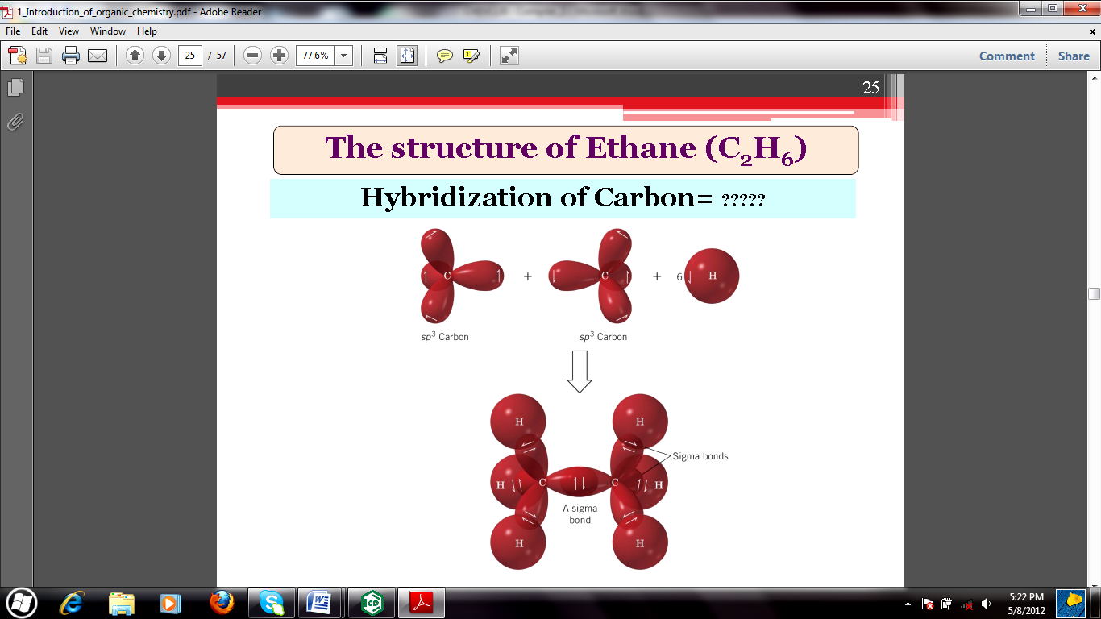

The four s-sp3 in methane (CH4) are localized molecular orbitals that define its tetrahedral structure.

sp3 hybridization is extended to compounds that contain C-C single bonds such as saturated alkanes e.g. ethane, propane, butane e.t.c.

The C-C single bonds allow free rotation in space that is analogous to ‘wheel and axle’ in motion, the axle resembling the bond in this case.

**1.2.2 sp2 hybridization (sp2 hybrid orbitals)**

In sp2 hybridization, one of the electrons in the 2s orbital is promoted to a 2p orbital. The 2s and two of 2p orbital are then hybridized resulting into three equivalent sp2 hybrid orbitalsthat are degenerate (see figure 5).

**Figure 5: illustration of sp2 hybridization**

The remaining orbital (one of 2p) is undisturbed.

The three sp2 orbitals all lie on the same plane and are directed to the corners of a equilateral triangle, a trigonal plannar arrangement. The bond angle is 1200.

The remaining 2p orbital is perpendicular to the plane formed by the three sp2 hybrid orbitals.

Each of the three sp2 hybrid orbitals has 33.3 % ‘s’ character and 66.6% ‘p’ character.

Each of the three sp2 hybrid orbitals contain a single electron such that the electronic configuration is (1s)2 (2sp2)1 (2sp2) 1 (2sp2) 1 (2p) 1.

Carbon uses sp2 hybrid orbitals to form sigma bonds with other carbon atoms such as the case of ethane (CH2CH2) molecule.

The undisturbed 2p orbitals of the two carbon atoms of ethene overlap in a side by side manner resulting into the formation of pi (π) molecular bond (see figure 6).



**Figure 6: Geometry of sp2 hybridization**

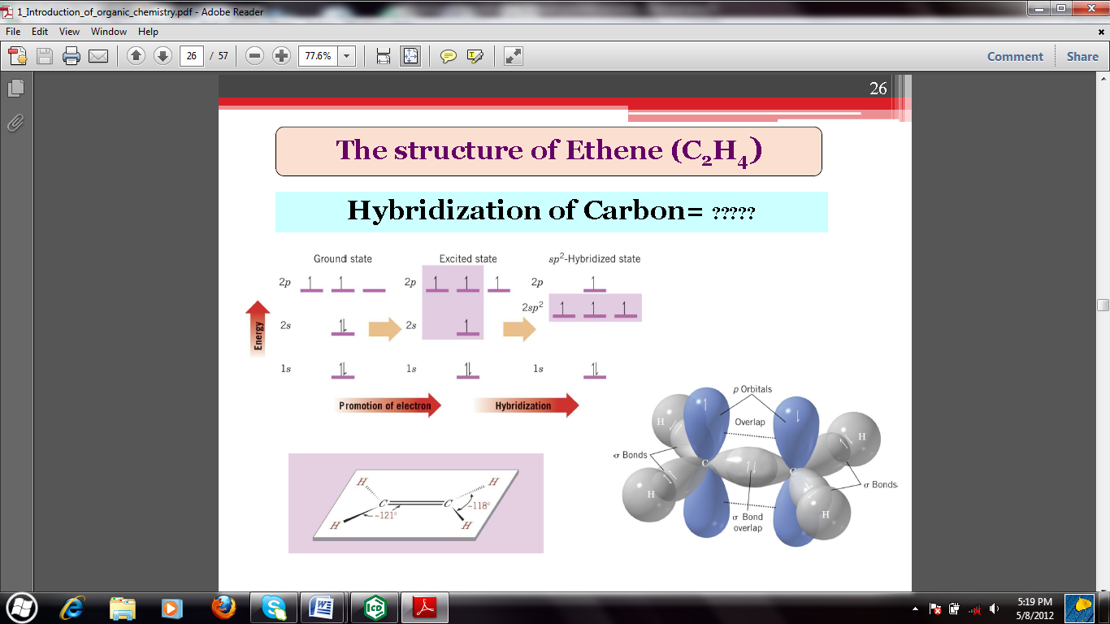

The trigonal arrangement occur in compounds that contain a double bond which is regarded as being made up of a strong sigma (**δ**) bond between two sp2 hybrid orbitals and a weaker pi (π) bond.

As opposed to the sp3 hybrid orbitals, there is restricted rotation about the double bond.

The C=C (double) bond is shorter than the C-C (single) bond because the electron pairs draw the nuclei more closer together than a single electron pair does.

Electrons in the π bond are less tightly held and are more polarized and so chemical reactions involving alkenes involve initial attack at the **π** electrons of the double bond.

**Structure and shape of the benzene C6H6 molecule:**

Benzene C6H6 is a cyclic compound with six carbon atoms joined in a ring. Each carbon atom is sp2 hybridised, and the ring is planar. Each carbon atom has one hydrogen atom bonded to it and an unhybridised 2p orbital perpendicular to the plane of the σ bonds of the ring. Each of these six 2p orbitals can contribute one electron for π bonding. This type of p-orbital system leads to complete delocalisation of all six π electrons giving rise to a highly stable structure of the benzene molecule.

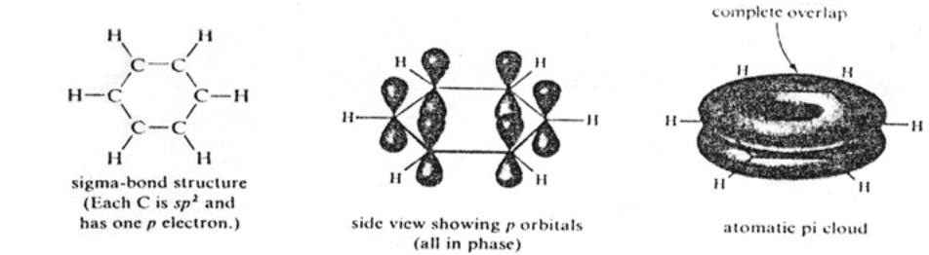

It is known that all carbon-carbon bond length in benzene is the same, 0.140 nm. All six bonds are longer than C=C double bonds, but shorter than C-C single bonds. From the bond lengths plus a body of other evidence, chemists have concluded that benzene is a symmetrically molecule with six ring σ bonds (C-C bonds) and six σ bonds of C-H bonds. Instead of alternating double and single bonds, the six π electrons are completely delocalised in a cloud of electronic charge above and below the ring.

**1.2.3 sp hybridization (sp hybrid orbitals)**

A combination of the 2s with only one 2px orbital makes results into formation oftwo sp hybrid orbitals. These orbitals extend in opposite directions from the carbon atoms (see figure 7).

**Figure 7: illustration of sp hybridization**

The angle between the hybrid orbitals is 180oso as to minimize the repulsion between the electrons placed in these two sp2 orbitals.

The remaining two valence electrons occupy the other two 2p orbitals (2py and 2pz) that are mutually perpendicular to the two sp hybrid orbitals.

sp hybridization results into a linear bonding arrangement.

Each sp hybrid bond has 50% ‘s’ character and 50% ‘p’ character. The two sp orbitals share a common axis but their lobes are oriented in opposite directions.

The C – C triple bond in alkynes is viewed as multiple bonds of the **δ**+**π + π** type. The triple bond is composed of one sigma bond formed by the overlap of sp hybrid orbitals from each carbon plus two **π** bonds that arise from the 2py& 2pz overlaps.



**Figure 8: Geometry of sp hybrid orbital**

Shorter bonds tend to be stronger bonds. As the ‘s’ character increases, the electron pairs are more strongly leading to contraction of the inter nuclear distance held hence requiring more energy to cleave/break.

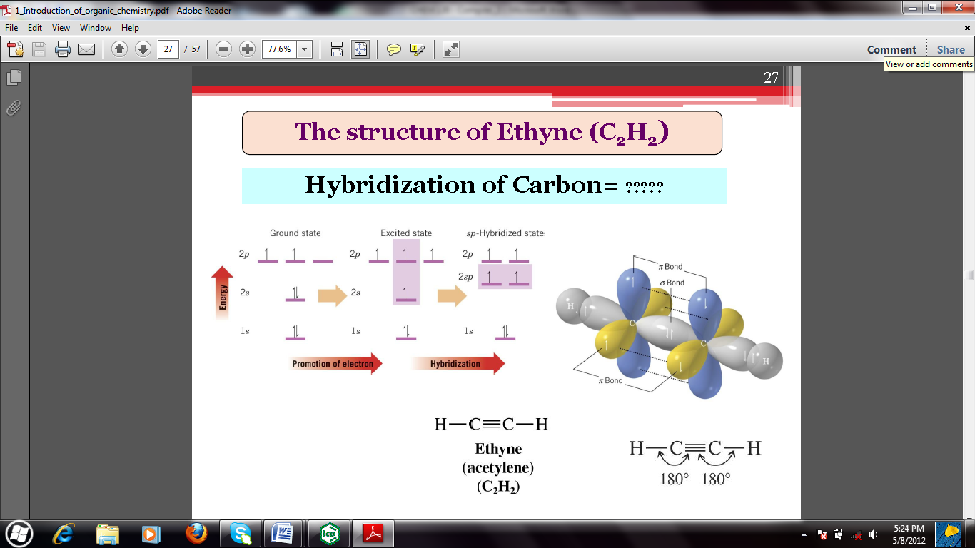

**In summary:**

| Hybridization | Geometry | Approximate  Bond angles | Number of Hybrid  orbitals | Number  of  remaining  orbitals | Number of sigma  bonds | Number of  pi bonds |
| --- | --- | --- | --- | --- | --- | --- |
| sp3 | Tetrahedral | 109.50 | 4 | 0 | 1 | 0 |
| sp2 | Trigonal  planar | 1200 | 3 | 1 | 1 | 1 |
| sp | linear | 1800 | 2 | 2 | 1 | 2 |

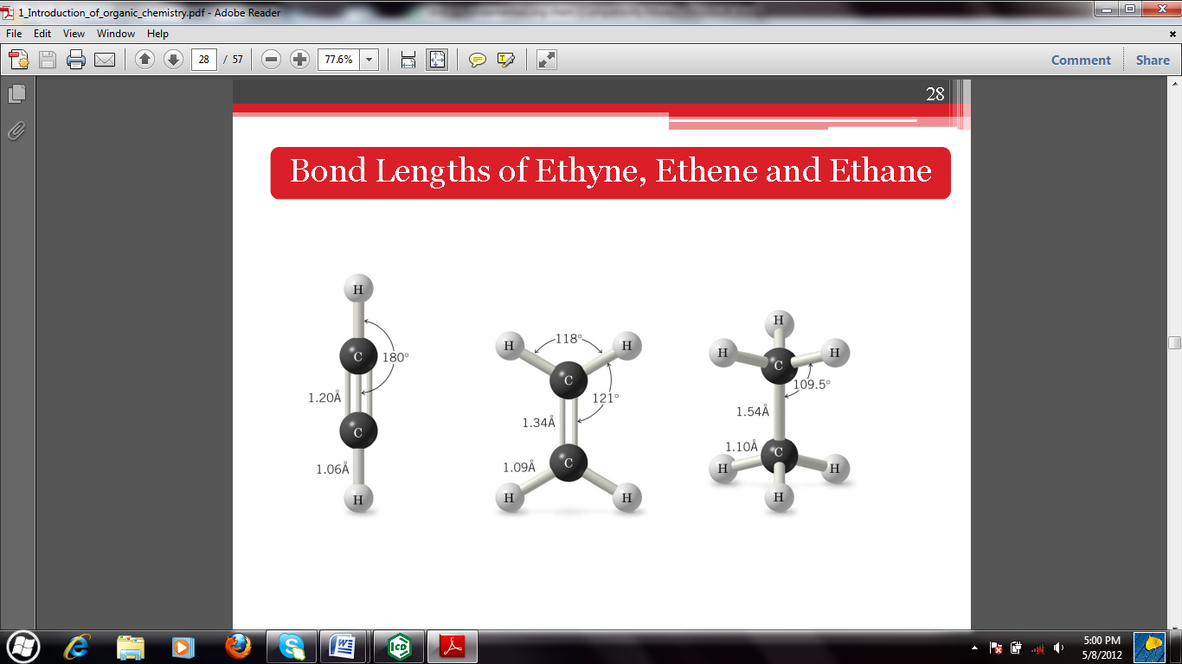

As the hybridization of carbon becomes more ‘s’ like and less ‘p’ like, the bond length decreases and the bond energy increases.

| **Bond** | **C-C** | **C=C** | **CC** |
| --- | --- | --- | --- |
| **Bond enthalpy kJmol-1** | 346 | 610 | 835 |

In the molecule given below, the arrows indicate selected atoms and bonds. Write the correct type of hybridization in the case of selected atoms and the type of bonding (sigma, pi or both) for the selected bonds.



Determine the geometry of the following molecules and hence specify the hybridization state of all the central carbon atoms.

* CH3CH=CH2
* (CH3)3CH
* CH3CN

The following two compounds have the same molecular formula C5H8 but different structures :





Give the hybridisation states of all carbon atoms for both compounds.

**1.3 Elemental analysis (qualitative)**

Common elements found in organic compounds include C, H, N, O, P, S, Br and certain metals.

The molecular formula gives the exact number of atoms of each element in one molecule of the compound.

The molecular formula of a given compound is determine by two step process:

* Determination of the empirical formula, which is the simplest whole number ratio of atoms of different elements present in the compound.
* Determination of molecular weight of the compound using mass spectrometer instrument.

Problem.

A compound was found to contain 42.9% C, 2.4% H, 16.7% N and 38.1% O by weight. Find its molecular formula given that its molecular weight is 168 g/mol.

Solution:

C H N O

Mass in 100g 42.9 2.4 19.7 38.1

Moles (42.9/12) (2.4/1) (16.7/14) (38.1/16)

Moles 3.58 2.4 1.19 2.38

Ratio of atoms (3.58/1.19) (2.4/1.19) (1.19/1.19) (2.38/1.19)

Ratio of atoms 3 2 1 2

The empirical formula is C3H2NO2

N/B The calculation may not give the actual integers at this stage. It may give ratios such as 1.5: 1 or 1.33:1 or 1.67:1. These rendered in the lowest integral equivalents i.e. 3:2, 4:3, 5:3 respectively.

The molecular formula is integral multiple of the empirical formula. Given that the molecular weight is 168. The molecular weight can be computed as follows:

(C3H2NO2)n = 168

84 n = 168

n = 2

The molecular formula is C6H4N2O4

**1.4 Hydrocarbons**

Hydrocarbons are compounds containing carbon and hydrogen only.

Hydrocarbons are divided into two main classes: Aliphatic and Aromatic, based on their structures.

Aliphatic hydrocarbons are further sub-divided into families/groups: Alkane, Alkenes, Alkynes and their cyclic analogues (see figure 9).



**Figure 9: Classification of hydrocarbons**

The molecules of both saturated and unsaturated **aliphatic** compounds are open-chain (**acyclic**) or simple rings (**cyclic**) structures.

The term **aromatic** refers to a major class of unsaturated cyclic organic compounds which includes **benzene** and its derivatives. Benzene is an unsaturated, but highly stable, cyclic molecule containing six carbon atoms.

**Aromatic hydrocarbons** are hydrocarbons which have benzene ring in their structures. They are sometimes called **arenes**.

| **Bond** | **C-C** | **C=C** | **CC** |
| --- | --- | --- | --- |
| **Bond enthalpy kJmol-1** | 346 | 610 | 835 |

**2.0 ALKANES**

Alkanes are saturated hydrocarbons with general formula CnH2n+2.

Cyclic alkanes have the general formula CnH2n.

Where n is an integer.

All the carbon atoms in alkanes are sp3 hybridized.

A series of compounds in which each member differ from the next member by a constant amount is called a **homologousseries**.

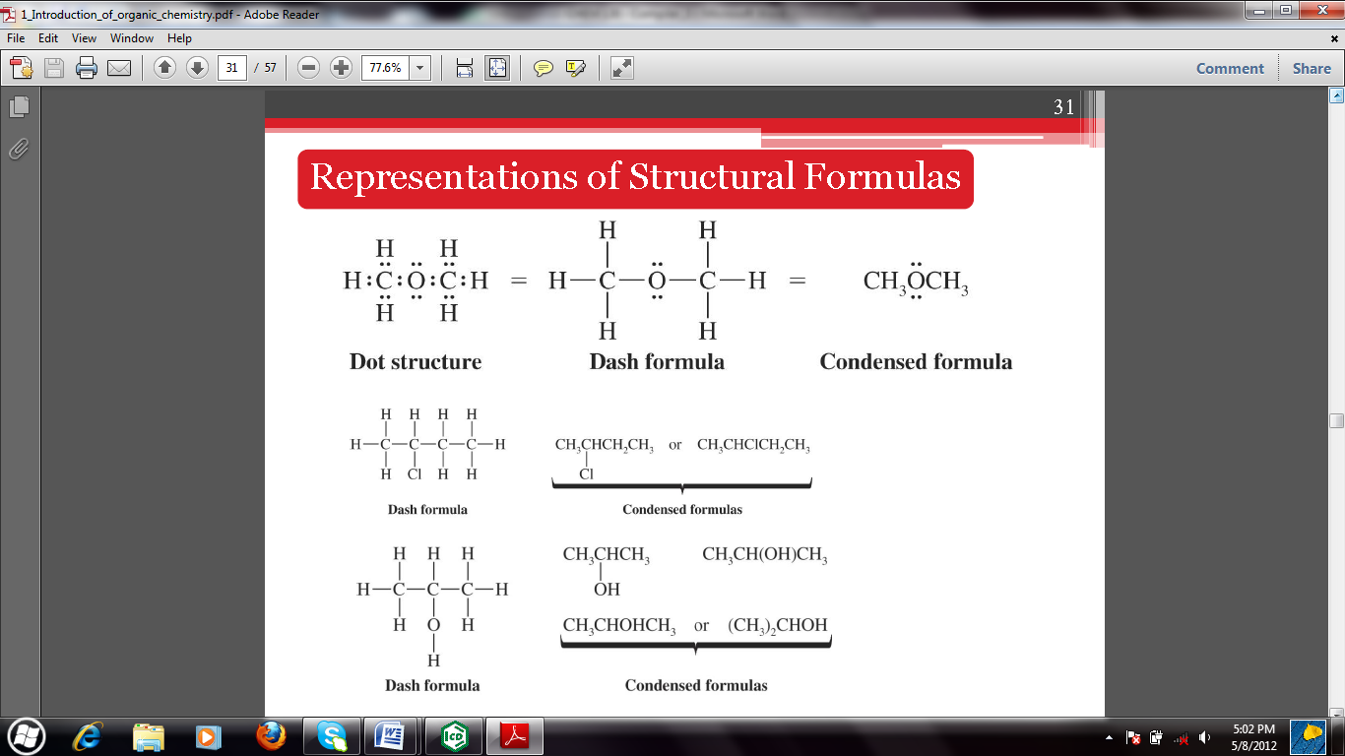

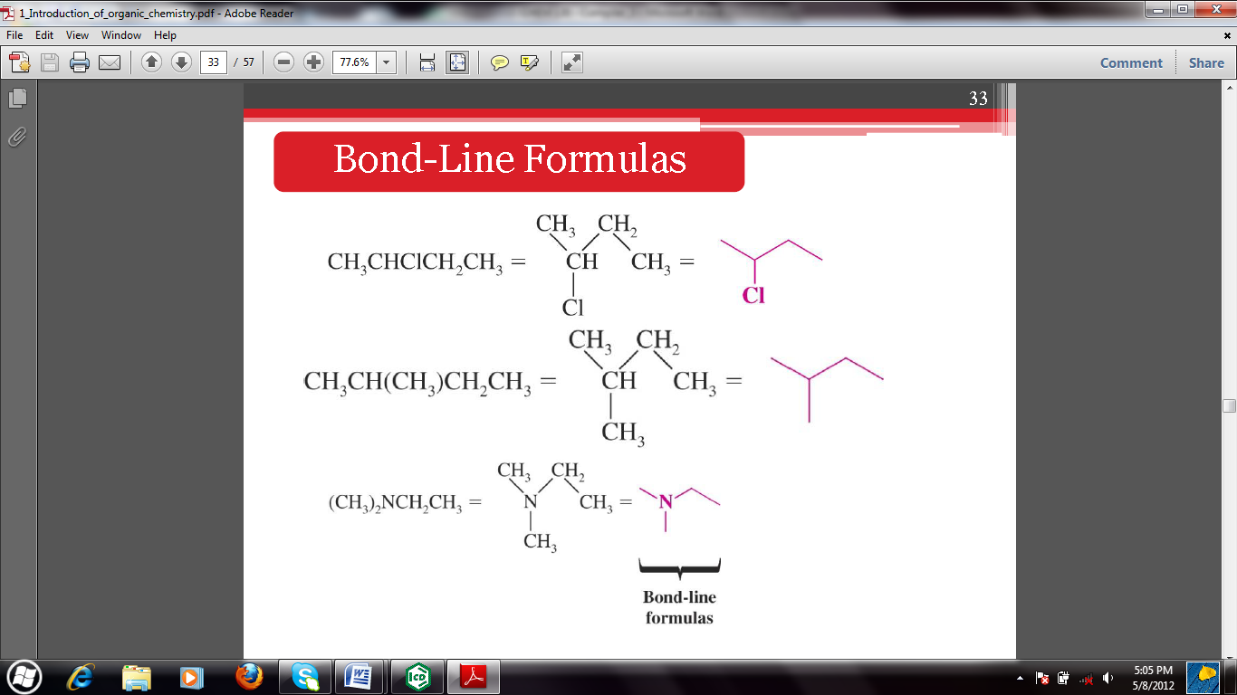

Homologous series of some straight chain alkanes include:

| **number of carbons** | **name** | **formula** | **structure** | **Line bond (or skeletal) structure** |
| --- | --- | --- | --- | --- |
| 1 | Methane | CH4 | CH4 |  |
| 2 | Ethane | C2H6 | CH3CH3 |  |
| 3 | Propane | C3H8 | CH3CH2CH3 |  |
| 4 | Butane | C4H10 | CH3(CH2)2CH3 |  |
| 5 | Pentane | C5H12 | CH3(CH2)3CH3 |  |
| 6 | Hexane | C6H14 | CH3(CH2)4CH3 |  |
| 7 | Heptane | C7H16 | CH3(CH2)5CH3 |  |
| 8 | Octane | C8H18 | CH3(CH2)6CH3 |  |
| 9 | Nonane | C9H20 | CH3(CH2)7CH3 |  |
| 10 | Decane | C10H22 | CH3(CH2)8CH3 |  |
| 11 | undecane | C11H24 | CH3(CH2)9CH3 |  |
| 12 | dodecane | C12H26 | CH3(CH2)10CH3 |  |
| 13 | tridecane | C13H28 | CH3(CH2)11CH3 |  |

N/B Straight chain alkanes are named according to the number of carbon atoms they have.

**2.1 Sources of alkanes**

1. Petroleum:

- is the primary source of alkanes.

- its is a complex mixture of organic compounds most of which are alkanes and aromatic

hydrocarbons.

- there are also small amounts of oxygen, nitrogen and sulfur containing compounds.

2. Fossil:

- Anaerobic oxidation of plant materials is a chief source of methane, the first member of the alkane family.Natural gas is mainly composed of methane.

**2.2 Nomenclature of alkanes**

There are two systems of naming:

1. Semisystematic (old system)
2. International Union of Pure and Applied Chemistry - IUPAC -(Current system)

Example:



**RULE 1:**

1. Find the longest continuous chain of carbon atoms and use the name of this chain as the base or parent of this compound.

Example:



* The longest continuous chain has 6 carbons and not 3 or 4 carbons. And it is considered the parent/base of the compound. Sometimes not obvious, you may need to turn corners.
* The group attached to the main chain is considered as branch and is called a **substituent**. And so methyl group is considered.
* If a hydrogen is removed from an alkane, the partial structure normally represented as “**R**-“ that remains is called an alkyl group. They are named by replacing the suffix “-ane” with ‘-yl’.
  + For example: CH4 – methane becomes CH3 – methyl. R = -CH3

C2H6 –ethane becomes C2H5– ethyl. R = -C2H5

* When the ‘R’ group is attached to a halogen, it is referred to as an akyl halide.
* Br-CH3  = Bromomethane, Cl -CH3 = Chloromethane are examples of alkyl halides.

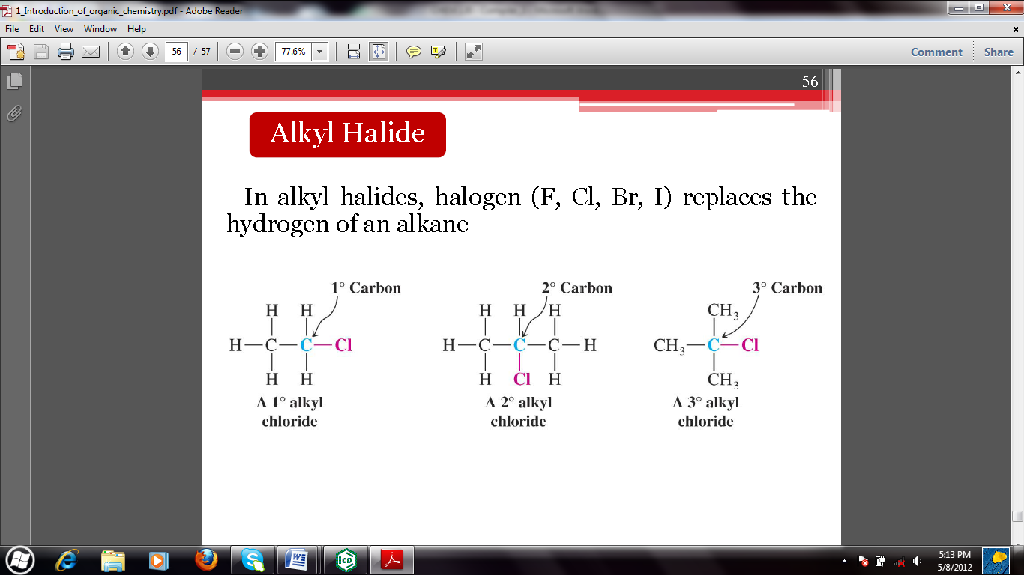

1. If two chains of equal length are present, choose the one with the larger number on branching points.



**RULE 2:**

Number the carbon atoms in the parent/main chain beginning at the end nearer to the first branching point. The first substituent encountered along the main chain receives the lowest possible number.



**RULE 3:**

Identify the number of substituents and locate each by the number assigned on the main chain according to its point of attachment.

* Use hyphens to separate various prefixes and commas to separate numbers.
* If there are two substituents on the same carbon, assign them both the same number.



**RULE 4:**

The parent alkane is the last part of the name and is preceded by names of the substituent groups and their numerical locations. Write the name as a single word.

* If two or more substituents are present, name them in alphabetical order.
* Use prefixes di-, tri-, tetra- if identical substituents are present on the main chain.
* The prefixes are ignored in determining the alphabetical order.





One further word in naming alkyl groups; certain prefixes can be used e.g. sec – (secondary), tert – (tertiary). There are four possibilities:



10 Primary 20 Secondary 30 Tertiaryand 40 Quartenary



Problems:

Identify the carbon atoms that are primary, secondary and tertiary in the structures drawn under rule 3 above.

Draw alkane that meets the following descriptions.

1. An alkane with two tertiary carbon atoms
2. An alkane with one secondary carbon atom.
3. An alkane with three primary carbon atoms.

**2.3 Structural isomerism in alkanes**

* Isomers are different compounds with similar molecular formula.
* Structural isomers (constitutional isomers) are compounds that have the same molecular formula but differ in the way atoms are arranged.

Example;

Butane (C4H10) has two isomers.



Problem:

Draw all the possible isomers of pentane and hexane.

**2.4 Physical properties**

The normal alkanes from C1 to C4 are gasses at room temperature e.g. methane.

C5 to C17 are liquids e.g. kerosene.

C18 onwards are solids e.g. wax.

* All organic compounds including hydrocarbons are less dense than water.

***Solubility***

* Alkanes are generally non polar and dissolve only in non-polar solvents such as benzene, ether and chloroform.
* Alkane are insoluble in water and other highly polar solvents. The non-polar nature of alkanes is due to the fact that atoms on alkane molecules are held together by covalent bonds.

***Melting point***

* Alkanes with even number of carbon atoms generally pack better into solid structure and therefore higher temperatures are required to melt them compared to those with odd number of carbon atoms. This is because alkanes with even number of carbon atoms pack so as to permit greater intermolecular attraction between the atoms.
* Highly symmetrical compounds often melt at abnormally high temperatures because molecule are also known to pack well in their crystal lattice.
* The highly branched alkanes melt at higher temperatures than the straight chain alkanes with the same number of carbon atoms. This is because branching gives it a more compact structure.

Problem:

Of the two isomers of butane, which one would be expected to melt at a higher temperature.

***Boiling point***

* Larger molecules have large surface areas resulting into increased intermolecular Van-der-waals forces of attraction. This is true in the case of straight chain alkane where the boiling points increase with increasing number of carbon. Decane (C10H22) has higher boiling point than pentane (C5H12)
* In general, highly branched alkanes have lower boiling points than normal (straight chain) alkanes.

With branching, the shape of a molecule tends to approach that of a sphere. As this happens, the surface area is decreased resulting into weaker intermolecular forces that would require lower temperatures to overcome.

Consider isomers the three of pentane C5H12.



| Bpt.(0C) | 36 | 10 | 28 |
| --- | --- | --- | --- |
| Mpt. (0C) | -130 | -20 | -160 |

* n-Pentane and 2-Methylbutane are larger isomers. They have larger surface areas and increased van-der-waals forces than 2,2-Dimethylpropane.
* 2,2-Dimethylpropane which is highly symmetrical has abnormally high melting point.

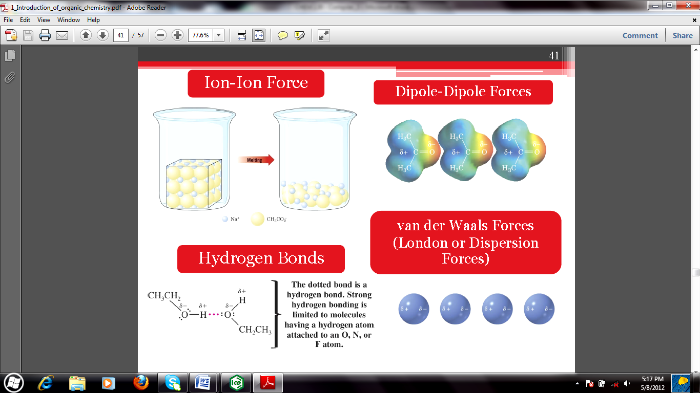

**2.5 Chemical reactions of alkanes**

The bonds in alkanes are single covalent and non-polar and hence they rarely react.

1. **Combustion**

Alkanes burn in air to give carbondioxide and water.



1. **Nitration**



1. **Oxidizing agent**

* Alkane can be oxidized by potassium permanganate (KMnO4).
* Only when the alkane is tertiary.



1. **Halogenation**

* Under proper conditions, alkanes react with halogens, X2 i.e. (Cl2, Br2,I2 & F2) to

form alkyl halides.



* If excess halogen is present, the reaction can proceed to polyhalogenated products.

1. **Pyrolysis (cracking)**



* The decomposition of a larger compound by means of heat alone in known as **pyrolysis**. The pyrolysis of alkanes particularly when petroleum is concerned is known as **cracking**.
* Cracking is mostly done in the industrial production of fuels.





**2.6 Mechanism for free radical substitution**

A reaction mechanism is a step by step by step description of the bond breaking and bond forming process that occurs when reagents react to form products.

Halogenations of alkanes occur via free radical (atom with one or more unpaired electron that is represented by a dot) chain reaction. It is a three step process.

1. The initiation step:



1. Propagation step



Termination step



**2.7 Cycloalkanes**

- Are alkanes in which the carbon atoms form a ring and the general molecular formula is CnH2n.

- Examples:



**Geometric isomerism**

* Are compounds with the same molecular formula but differ in orientation in space.
* examples:



* In addition to the monocyclic compounds, there are more complicated compounds with bridges linked across the rings. They are referred to as polycyclic.

**Nomenclature of cycloalkanes:**

* Cycloalkanes are named by adding the prefix ‘cyclo’ to the name on the corresponding open chain alkane with same number of carbon atoms in the ring
* The ring is numbered in the direction that gives the lowest possible numbers to the substituent groups at the first point of difference between the two directions. The alphabetical order of listing the groups still applies.
* Examples:



* When the ring contains fewer carbon atoms than the alkyl group attached, the compound is named as an alkane otherwise, it is named as a cycloalkane.



* According to the IUPAC system of cycloalkanes consisting of two rings only and having two or more atoms in common take the prefix ‘bicyclo’ followed by the name of the corresponding alkane.
* The number of carbon atoms in each of these bridges connecting the two carbon atoms is indicated in brackets in descending order.
* Numbering begins with one of the bridgeheads and proceeds by the longest possible path to the other bridgehead.
* Numbering then proceeds from this atom by the longer unnumbered path back to the first bridgehead and is completed by the shortest path.

Examples:





**2.8 Preparation of alkanes**

1. **Hydrogenation of alkenes**



1. **Reduction of alkyl halides by metal and acid**





**3. Use of Grignard reagent**

Alkyl halides in ether (solvent) reacts with magnesium to form an alkyl magnesium halide (Grignard reagent) which on treatment with water or dilute acids are decomposed to an alkane.



**4. Coupling of alkyl halides with organometallic**



**5. Wurtz reaction**



**6. Decarbonylation**

- By heating the sodium salt of a carboxylic acid in soda lime.



**3.0 ALKENES**

- Are unsaturated hydrocarbons with general formula CnH2n.

- A study of the reactions of alkenes is really the study of c=c double bond that consists of one

sigma and one pi bond.

- Due to the presence of the pi bond, that causes unsaturation, alkenes are more reactive than

alkanes.

- There is no free rotation about the c=c double bond. The double bond is rigid.

- older name of this family of compounds that is still often used is ‘**olefins**’

**3.1 Sources of alkenes**

- Catalytic cracking of petroleum

- Dehydration of ethanol that is produced by fermentation of carbohydrates.

**3.2 Nomenclature of alkenes**

* Names are derived by replacing the ending –ane of the corresponding alkane with –ene e.g

CH2=CH2 Ethene CH3CH=CH2 Propene

* The longest carbon chain with the double bond is considered to be the parent alkene.
* The chain is numbered in the direction that gives the double bonded carbon atoms the lowest possible numbers.
* The rules for naming alkanes are pretty much the same as those for alkanes **except**that the double bond is given **preference** in numbering the chain. This because the double bond is regarded as the functional group in the molecule.
* In substituted alkenes the numbers and names of substituents are mentioned first, followed by the position of the double bond and lastly by the name of the parent alkene.
* Examples
* :
* When two or more double bonds are present, the terminal –ane of the corresponding alkane is replaced by –adiene, atriene e.t.c to obtain the name of the compound e.g

CH2=CHCH=CH2 1, 3-Butadiene

* The longest chain containing both double bonds is taken to be the parent chain.



* If more than one substituent is present, the substituents are named in alphabetical order e.g.



* Cyclic alkenes are named by prefixing the word ‘cyclo-‘ or ‘bicyclo’ (whichever is applicable) to the name of the corresponding open chain alkene. The carbon atoms of the double bond are considered to be atposition 1. e.g.



* 1. **Structural isomerism in alkenes(Cis ,Trans, E, Z)**
* Rigidity and lack of rotation of theC=C double bonds in alkenes give rise to ‘Cis’ and ‘Trans’ geometric isomerism depending on how the groups attached to the double bond are oriented in space.
* The different spatial arrangement of the groups around the double bond give rise to difference in chemical properties.
* Geometric isomerism cannot exist if either of the doubly bonded carbon atoms carry identical groups. e.g.



* However, the ‘Cis – Trans’ nomenclature system can only be applied to a small number of alkenes.
* For instance the ‘Cis – Trans’ system cannot distinguish between the two isomers of 2-Bromo-1-chloro-1-flouroethene.



* In the modern ‘E-Z’ system of the Cahn Ingold Prelog convention, priorities are assigned to each of the two groups attached to each of the two carbons based on their atomic numbers.
* We simply consider the two groups attached to the same carbon atom of the double bond and decide which has a higher priority.
* The higher the atomic number, the higher the priority.
* When higher priority groups at each carbon atom are on the same side, the isomer is designated letter (Z) (zusamen meaning together).
* It two groups of higher priority are on opposite sides of the double bond, it is designated letter (E) (entegen meaning opposite).
* Examples:





* Trans-alkenes are usually higher melting than their cis isomers because of higher symmetry, but their boiling points differ very little.
* The cis-isomer has lower m.p., lower density and higher solubility than that of the trans-isomer. These properties can be explained by the existence of intramolecular hydrogen bonding in the cis-isomer, which reduces the chance of intermolecular hydrogen bonding, and thus weaken interactions between molecules of the cis-isomer.

**3.4 Physical properties of alkenes**

* The first three members of alkenes are gases at room temperature (C2-C4), C5-C15 are liquids at room temperature and >C15 are solids at room temperature.
* They burn with a luminous flame.
* They’re insoluble in water, but more soluble than alkanes in some polar solvents like alcohols.
* They’re less volatile than alkanes and their boiling points and melting points increase with increase in molecular mass.
* They are less dense than water.
* Boiling points increase with increasing number of carbons.

**3.5 Preparation of alkenes**

1. **Dehydrohalogenation of alkyl halides**



1. **Dehydration of alcohols**

* Alcohals are converted to alkenes elimination of a water molecule (dehydration).
* This occurs in the presence of an acid and some heat.



1. **Dehalogenation of vicinal dihalides**

* The method is purely 1,2-elimination of the vicinal halides.



1. **Reduction of alkynes**



* The hydrogenation here is partial.
* The ‘cis’ alkene product is almost 98%.

* 1. **Chemical reactions of alkenes**
* Most reactions occur at the double bond because it is the functional group.
* The double bond is an electron rich centre. These electrons attack nuclei of other atoms that are relatively electron deficient.
* The pi electrons of alkenes are therefore nucleophilic and react readily with electrophiles.

1. **Addition of hydrogen (Reduction)**





1. **Halohydrin formation**



1. **Addition of sulphuric acid**



1. **Addition of hydrogen halide (Markovnikovs rule)**

* Addition of hydrogen halide to alkenes is governed by Markovnikovs rule.
* The rules states that when an acidic molecule adds to an asymmetric alkene, the major product is the one in which the hydrogen atom attaches itself to the carbon atom already carrying the larger number of hydrogen atoms.
* The reverse rule is referred to as ‘Antimarkovnikov’ when hydrogen peroxide (or any other peroxide) is used.
* Alkenes form addition products with halogen acids in the following order of reactivity:

HI > HBr > HCl > HF . HI being the most reactive while HF being the least reactive.





1. **Hydration of alkenes**

* Addition of H2O across the double bond in the presence of dilute acid to form an alcohol.



1. **Ozonolysis**

* This reaction is used to determine the location of the double bond in alkenes because it involves cleavage of the double bond to give carbonyl compounds.
* Ozone is considered a mild oxidant.





1. **Oxidation of alkenes**
2. Moderately strong oxidizing agents

e.g. HIO4 or (CH3COO-) 4Pb



1. Strong oxidizing agents

They include acidified K2Cr2O7 or acidified KMnO4.



1. **Hydroboration of alkenes**

* Alkenes undergo hydroboration with diborane (BH3)2 to yield a trialkylborane (R3B), which upon oxidation gives an alcohol.



* The hydroboration – oxidation process gives products that correspond to anti-markovnikovs addition of water across the double bond.



1. **Polymerization**

* A process that involves the joining together of many small molecules to form very large molecules.
* The small molecules that form polymers are called monomers.
* When ethene it heated under high pressure with oxygen, a compound of high molecular weight (approx. 20,000) is obtained which is essentially an alkane.



* A compound made of many ethene (or ethylene) units is called polyethene (or polyethylene).
* Polymerization of substituted ethylenes is also possible. e.g. polyvinylchloride that used to make plastic pipes.

* 1. **Qualitative test for alkenes**
* Qualitative tests involve the detection of the presence of alkenes or basically test for unsaturation.
* Important general laboratory observations in testing mostly include:
  + Colour changes or disappearances
  + Effervesence or bubbles of a gas produced
  + Peculiar smell
  + Formation of precipitate
  + Flame produced during burning i.e. luminous or non-luminous, sooty or not
  + Water droplets on the surface of test tube during heating.

1. **Bromine test:**

* Addition of Br2 in CCl4is used for the detection of the C=C double bond.



* Alkenes decolorize Bromine water (Orange) or Bromine in CCl4 (Red).

1. **Baeyer’s test:**

* Cold dilute KMnO4 solution (Baeyer’s reagent) is also decolorized by alkenes.



**4.0 ALKYNES**

- Another class of unsaturated hydrocarbons with a general formula CnH2n-2 n=2,3,4…..

- They contain carbon carbon tripple bonds as their functional group.

- The triple bond is made of one sigma bond and two pi bonds.

**4.1 Sources of alkynes**

- The simplest member of this group is acetylene (or ethyne) C2H2 and is of chief industrial importance. It is obtained by:

(a) Reaction of water and Calcium carbide.

(b) High temperature oxidation of methane.

**4.2 Nomenclature of alkynes**

* Alkynes are named in the same way as alkanes. The terminal –ane in the corresponding alkane is replaced by –yne. The location of the triple bond is indicated by a number in such a way that the carbon preceding the triple bond is given the lowest possible number.
* The hydrogen atom attached to the carbon of the triple bond is called **acetylenic** hydrogen which is weakly acidic and can be removed by a strong base.



* The locations of the substituent groups attached to the branched alkynes are also indicated by numbers.



* When the molecule contains more than one triple bond the suffix –ane of the corresponding alkane is replaced by a –di yne (2 triple bonds), -atriyne (3 triple bonds) etc.



* When both a double bond and a triple bond are present in the same molecule, then the hydrocarbon is called an **alkenyne**. The multiple bonds are given numbers as low as possible.



* Double bond takes preference over the triple bond when there is a choice in numbering that is given the lowest number possible.



* Ketones also takes preference over the triple bond when there is a choice in numbering that is given the lowest number possible.



* When a triple bond and an alcoholic group (-OH) are present, the –OH comes last and the numbering is done from the end bearing the –OH group e.g.





**Isomerism in alkynes**

The first two alkynes do not show any isomerism.

1. **Position isomerism**

Due to the various structures obtained by varying the position of the triple bond e.g.



1. **Structural isomerism**

Caused by differences in the type of carbon chain e.g.



1. **Functional isomerism**

Alkynes can be visualized as isomers of dienes (or alkenes) e.g.



**N/B** Unlike alkenes, alkynes do not show geometric isomerism.

* 1. **Physical properties of alkynes**
* They are less generally volatile than either alkanes or alkenes.
* C2-C4 are gases, C5-C13 are liquids and >C13 are solids.
* They are colorless and odorless compounds, except ethyne which has a garlic odor.
* The boiling points, melting points, densities and heat of combustion increase with increase in molecular mass.
* They’re sparingly soluble in water but readily soluble in organic solvents.

**4.5 Chemical reactions of alkynes**

* Alkynes undergo reactions typical to those of alkenes. The triple bond is the functional group.

1. **Hydrogenation (Addition reaction)**

It occurs in 2 stages.



* Reduction of an alkyne at the double bond stage can unless the triple bond is a terminal one, yield either Cis - alkene or Trans - alkene. Whichever of the two predominates depend kind of the reducing agent.



1. **Reaction with haloacids (HCl, HBr)**



1. **Reaction with halogens (Br2, Cl2)**



1. **Hydration (addition of H2O)**

* Like alkenes, alkynes can also be hydrated in the presence of an acid (and HgSO4 for simple) and water.
* The process leads to keto-enol tautomerism. Compounds whose structures differ markedly in arrangement of atoms but which exist in easy and rapid equilibrium are called **tautomers**.
* The keto tautomer is mostly favored.



1. **Reaction with Alkylmagnesium halide or alkyllithium**

* Only works with terminal alkynes



1. **Ozonolysis**



1. **Reaction of metal acetylides and alkynyl/Grignard reagent with carbonyl (Aldehyde and Ketones)**







**4.6 Preparation of alkynes**

1. **Calcium carbide**

* Used for laboratory as well as industrial preparation of ethyne.



1. **Dehydrohalogenation of alkyl dihalides**

* This involves double dehydrohalogenation of dihaloalkanes. The dihalide may be a vicinal or geminal.



1. **Reaction of sodium acetyledes with primary alkyl halides**

* Used in the conversion of smaller alkynes to a larger ones.
* Sodamide (NaNH2) in liquid ammonia is a strong base capable of abstracting the acetylenic hydrogen from the terminal alkyne.
* The smaller alkyne must be terminal and the alkyl halide must be primary.



* 1. **Qualitative test for alkynes**

1. **Bromine test**

* They also decolorize Br2 in CCl4.



1. **Baeyer’s test**

* Cold dilute KMnO4 solution (Baeyer’s reagent) is also decolorized by alkenes.
* Alkynes are oxidized to carboxylic acid.



1. **Ammoniacal silver nitrate or Ammoniacal copper nitrate**

* Terminal alkynesgive a white precipitate when treated with ammoniacal silver nitrate.
* This distinguishes between terminal and non-terminal alkynes.
* Terminal alkynesgive a brick red precipitate when treated with ammoniacal copper nitrate.





**5.0 FUNCTIONAL GROUPS**

- A **functional group** is an atom, a group of atoms, or a bonding arrangement, which is responsible for thecharacteristic reactivity and physical properties of an organic compound or class of compounds.

- The structure of a typical carbon compound can be considered as two parts : a saturated carbon-hydrogen ‘skeleton’, which is comparatively unreactive, and a reactive part consisting of one or more functional groups. Two examples are shown below :



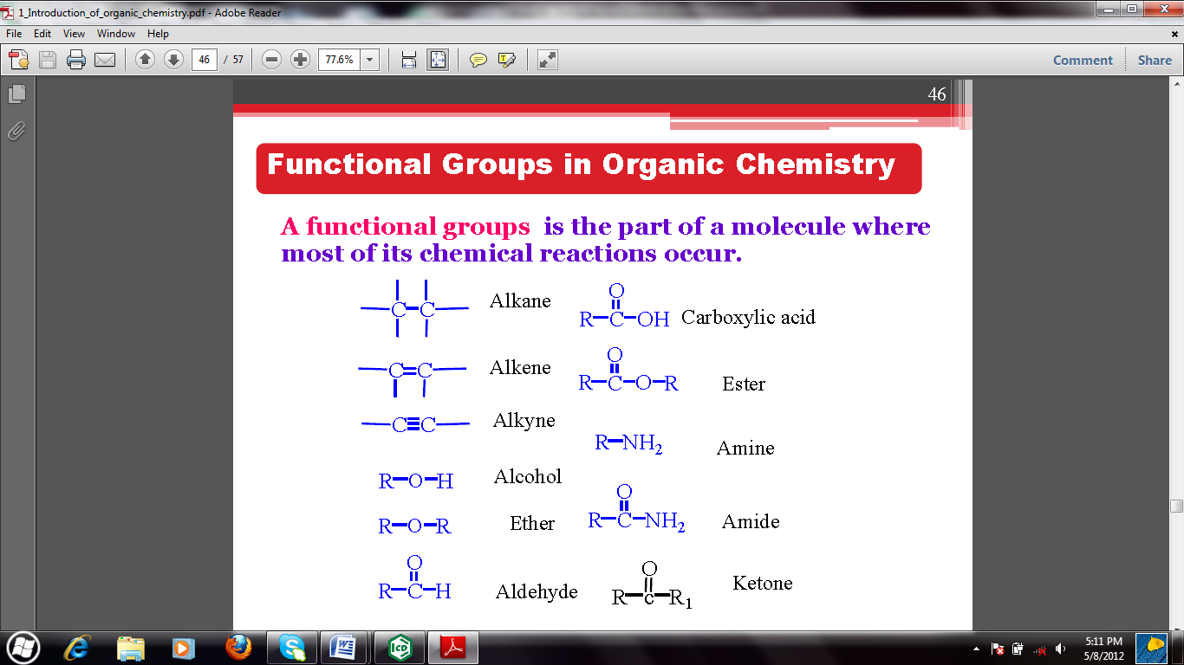

* In the event that there are more than one functional group in a molecule, the following order of preference is given in the choice of the principal functional group which is to be given the lowest number.

1. Carboxylic acids
2. Aldehydes
3. Ketones
4. Alcohals
5. Double bond
6. Tripple bond
7. Atoms and alkyl groups.
8. Alkanes

* 1. **ALCOHOLS (ALKANOLS)**
* These are organic compounds of the general formula R-OH, where the hydroxyl group (-OH) is attached to an alkyl group(R) or cycloalkyl group.
* The OH group is the functional group of the alcohol and determines their reactivity and characteristics. They from a homologous series of the general formula CnH2n+1OH, where n is the number of carbon atoms. E.g CH3CH2OH.

**Nomenclature (IUPAC rules)**

1. Name the longest carbon chain to which the hydroxyl group is attached. The chain name is obtained by dropping the final **e** from alkane name and adding the suffix **–ol.**
2. Number the chain starting at the end nearest the hydroxyl group and use the appropriate number to indicate the position of the –OH group. NB; in numbering the longest carbon chain, the hydroxyl group has priority over double and triple bond as well as over alkyl, cycloalkyl and halogens substituents.
3. Name and locate any other substituent present.
4. In the alcohol where the –OH group is attached to a carbon atom in a ring, the hydroxyl group is assumed to be on carbon 1.

Examples





**Physical properties of alcohols**

1. Boiling points of alcohols are higher than those of the hydrocarbons of approximately the same molecular weight. This is due to hydrogen bonding between alcohol molecules.



1. Alkanols are soluble in water. Their solubility however decreases gradually as the hydrocarbon part of the molecule increase.

**Classification of alcohols**

They are classified as primary (10), secondary (20) or tertiary(30) depending on the number of carbon bearing groups attached to carbon bearing hydroxyl (-OH).

**Primary** alcohol is an alcohol in which the hydroxyl bearing carbon is attached to only one other carbon, a **secondary** alcohol is an alcohol in which the hydroxyl bearing carbon is attached to two other carbon atoms while a **tertiary** alcohol is an alcohol in which the hydroxyl bearing carbon atom is attached to three other carbon atoms.

Examples



**Qualitative test for alcohols**

**Lucas test:**

* 10, 20 and 30alcohols are distinguished based on their reactivity towards hydrogen halides (Lucas test). Lucas reagent, a mixture of conc.HCl/ZnCl2. The reaction proceeds and the alcohol is converted to alkyl halide.



* Formation of alkyl chloride is indicated by cloudiness that appear when the chloride separates from the solution; hence the time required for cloudiness to appear is a measure of reactivity of the alcohol.

30 alcohol – forms cloudiness immediately

20 alcohol - forms within 5 minutes

10 alcohol – do not form appreciably at room temperature.

* 1. **CARBOXYLIC ACIDS**
* They have the general formula R-COOH.
* They are named by replacing the –ane of the corresponding alkane with –oic acid.
* The functional group (-COOH) is always terminal.
* The carbonyl carbon (C=O) is assigned position 1 in numbering the longest chain.

Examples:



**Qualitative test for carboxylic acids**

**Sodium hydrogen carbonate**

* Carboxylic acids react with sodium hydrogen carbonate to give a precipitate.



* 1. **KETONES**
* They have the general formula RCOR.
* They are named by replacing –e in the corresponding alkane with –one.
* The carbonyl carbon (C=O) takes priority in numbering the longest chain.

Examples



**Qualitative test for ketones**

**Iodoform/Haloform test.**

* Used to distinguish methyl ketones
* Aqueous solutions of iodine and potassium iodide are added to basic solutions of 2-pentanone and 3-pentanone. The iodoform reaction is a classical test for methyl ketones.
* A light yellow precipitate of iodoform forms immediately with the methyl ketone 2-pentanone.

|  |  |
| --- | --- |

* 1. **ALDEHYDES**
* They have the general formula R-CHO.
* They are named by replacing –e in the corresponding alkane with –al.
* The carbonyl carbon (C=O) is always terminal.

Examples:



**Qualitative test for aldehydes**

**Fehling’s test:**

* This test is very specific for aldehydes; only aldehydes will give a positive result. Any alcohol or ketone will give a negative result.
* It is basedupon the ability of the aldehyde group to reduce the Cu+2 ion of Cu(OH)2 (which

is blue) to the Cu+1 ion of Cu2O (which is dark red) in the presence of a base.



**Silver mirror test/ Tollens’ reagent**.

* Most Aldehydes reduce Ammoniacal Silver Nitrate solution to give a precipitate of Silver metal (pronounced coating on test tube wall).

